Book 4 Unit 5 THEME PARKS — FUN AND MORE THAN FUN

Pre-reading activities

Task I. Do you like to go to parks? What can you see in a park?

Task II. What do you know about Disneyland?

Task III. If you had a chance to travel in the world, which country would you choose? Why?

While-reading activities

Task I. Read the text and fill in the blanks in the chart.

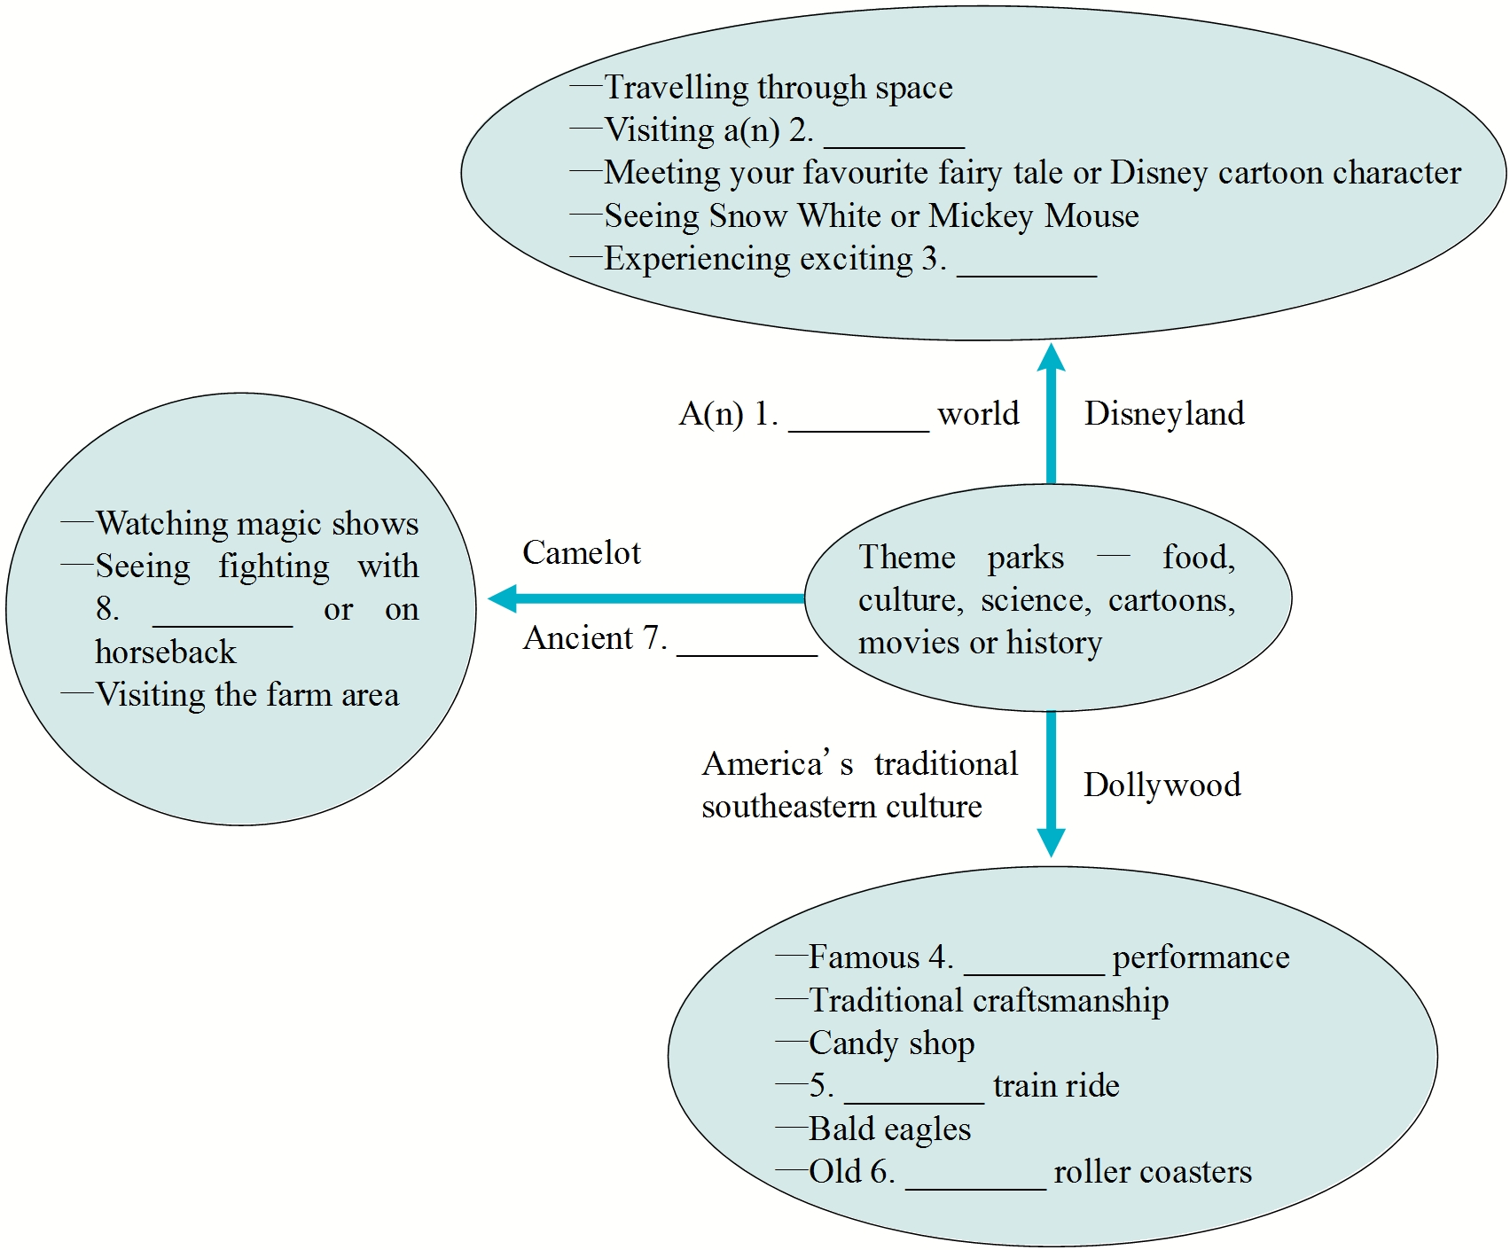 Task II. Read the text and put the statements into the right column.
A. Famous country music groups perform here all year round.
B. It is a magical world where your dreams can come true.
C. You can experience the life and great deeds of English people.
D. People come to see things made in traditional ways.
E. You can meet Snow White and Mickey Mouse in the street.
F. You can see sword fights or fights on horseback in the jousting area.
G. You can learn how people in ancient England ran farms and cared for their animals.
H. You can enjoy many exciting rides, including giant swinging ships and terrifying free-fall drops.
I. Here a working steam-engine train may be found.
J. You can take a ride on one of the best old wooded roller coasters.
K. It is a fantasy world modelled after ancient England.
Disneyland
Dollywood
Camelot

Post-reading activities
Task I. Write a summary of the text.
_____________________________________________________________________________
_____________________________________________________________________________
_____________________________________________________________________________
_____________________________________________________________________________
_____________________________________________________________________________

Task II. List the things that you can experience in Disneyland according to Paragraph 2.

Task III. Why do you think people like to visit the theme parks?

Task IV. Write a short essay to introduce one of the parks that you visited.

参考答案：
Pre-reading activities
Task I. 略
Task II．略
Task III．略

While-reading activities
Task I. 1. magical 2. pirate ship 3. rides 4. country music
5. steam-engine 6. wooden 7. England 8. swords
Task II. Disneyland: B, E, H
Dollywood: A, D, I, J
Camelot: C, F, G, K

Post-reading activities

Task I.
Whatever you are interested in, there is a theme park for you. Disneyland is probably the most well-known. Go there and you may see Snow White or Mickey Mouse. With its many exciting rides, tourism increases wherever there is a Disneyland. Going on rides is not the main attraction at Dollywood in the Smoky Mountains though. Famous country music groups perform there all year round. People come to Dollywood to see craftsmen make wood, glass and iron things the old-fashioned way and try candy made as it was 150 years ago. Ride on a steam engine and Thunderhead, an old wooden roller coaster, to make your visit complete. Finally at England’s Camelot Park, you can enjoy the days of King Arthur and the Knights of the Round Table and see how people in ancient England took care of their animals. (By Ray Cama)

WORDS & EXPRESSIONS
preserve
【归纳】 preserve既可作动词，也可作名词。
★作动词时，意为：①保护，维护；②保存，保留；③贮存，保鲜。如：
We must encourage the planting of new trees and preserve our existing woodlands.
Few of her early poems have been preserved.
The ship is equipped with special fridges to preserve food and vegetables.
★作名词时，意为“野生动物保护区”。如：
No hunting is allowed in the preserve.
【即学即练】 翻译下面句子。
1. It is one of the duties of the police to preserve public order.
____________________________________________________________
2. I think these interesting old customs should be preserved.
____________________________________________________________
3. You can preserve meat or fish in salt.
____________________________________________________________
参考答案
preserve
【即学即练】
1. 警察的职责之一是维护公共秩序。
2. 我认为这些有趣的旧习俗应该保留下来。
3. 你可以用盐保存肉或鱼。
advance
【归纳】 advance既可作名词，也可作动词。
★作名词时，意为：①前进，行进；②进步，进展。如：
They tried to stop the enemy’s advance.
Recent advances in medical science mean that this illness can now be cured.
★作动词时，意为：①前进，行进；②发展，进步；③使提前。如：
According to one report, the water is advancing at a rate of between 5cm and 7cm a day.
We have advanced greatly in our knowledge of the universe.
The date of their wedding has been advanced by one week.
【拓展】
in advance 提前，预先
in advance of （时间上）在……前
advanced adj. 先进的，高级的
【即学即练】 根据括号内的汉语提示补全下面句子。
1. You must _______________________ (预先付书的钱).
2. The date of the meeting _______________________ (由6月10日提前到6月3日).
3. Our troops _______________________ (已经前进了两英里) so far.
参考答案
advance
【即学即练】
1. pay for the book in advance
2. was advanced from 10 to 3 June
3. have advanced two miles
swing
【语境展示】阅读下面句子，并试着归纳swing的意思。
1. The swing of the ship made everyone seasick.
2. There are some swings in the park for the children.
3. His arms often swing as he walks.
4. He sat on the bench, swinging his legs.
【自我归纳】
★swing作名词时，意为：①摇摆(句1)；②秋千(句2)。
★swing作动词时，意为“(使)摆动，摇摆”(句3-句4)。
【即学即练】翻译下面句子。
1. 在身体两侧随意摆动你的手臂。
______________________________
2. 那只猴子从一个树枝摇荡到另一个树枝。
______________________________
参考答案
swing
【即学即练】
1. Swing your arms freely at your sides.
2. The monkey swings from branch to branch.

be famous for
【归纳】 be famous for意为“因……而闻名”。主语是人时，表示某人以某种知识、技能或特点等而闻名；主语是地方时，表示某地以某种特点或特产等而闻名。如：
The woman was internationally famous for her novels and poetry.
France is famous for its wine.
The company is famous for selling lots of books on the Web.
【拓展】 be famous as意为“作为……而出名”。主语是人时，表示某人以某种身份出名；主语是地方时，表示某地作为某事物的产地或人物的出生地等而出名。如：
Mo Yan is famous as a writer.
Virginia is famous as the birthplace of several US presidents.
【即学即练】 用适当的介词填空。
1. The town is famous ________ its hot springs.
2. Mr. Brown is famous ________ both a teacher and researcher.
3. Mother Teresa is famous ________ her work with the poor.
参考答案
be famous for
【即学即练】
1. for 2. as 3. for

SENTENCE EXPLANATIONS
请和你的同学一起认真分析下面句子，并补全所缺内容。这种学习方式能逐步提高你理解长难句的能力。
1. It will bring you into a magical world and make your dreams come true, whether you are travelling through space, visiting a pirate ship or meeting your favourite fairy tale or Disney cartoon character. (P₃₄)
【分析】
① 本句是一个主从复合句。
② It will ... come true是主句，and连接两个并列的谓语动词bring和________，其中come true为固定短语，表示“（预言、期望、梦想等）实现，成为现实”。
③ whether you are travelling ... character在句中是让步状语从句。
【句意】无论你是在太空遨游，参观海盗船，还是邂逅你最喜欢的童话故事或者迪斯尼卡通里的人物，迪斯尼会把你带到魔幻的世界，使你的梦想变为现实。
【仿写】无论你是在湖上划船, 欣赏美景，还是在公园里和朋友一起散步，杭州的西湖都会把你带进一个快乐的世界，让你忘记烦恼与忧愁。
The West Lake in Hangzhou ____________________ and make you forget your worries and sadness, ________ you are boating on the lake, enjoying the beautiful scenery ________ taking a walk in the park with your friends.
2. With all these attractions, no wonder tourism is increasing wherever there is a Disneyland. (P₃₄)
【分析】
①本句是一个主从复合句。
②no wonder前省略了it is，其后跟省略了连接词that的主语从句。
③wherever there is a Disneyland是________ 从句。
【句意】有这么多引人入胜的东西，难怪哪里有迪斯尼乐园，哪里的旅游业就会发展。
【仿写】玛丽有这么好的性格，难怪她到哪里，都有人愿意和她交朋友。
____________________________________________________________
3. Visit the candy shop to try the same kind of candy that American southerners made 150 years ago, or take a ride on the only steam-engine train still working in the southeast USA. (P₃₄)
【分析】
①本句是一个由or连接的并列复合句。
②前一分句中不定式短语to try the same kind of candy作目的状语，其后的that引导定语从句，修饰________。
③后一分句中动词-ing形式短语still working in the southeast USA作定语，修饰________。
【句意】到糖果店品尝一下糖果，这些糖果和150年前美国南方人制作的一模一样。或者乘一乘蒸汽火车，这可是在美国东南部依然运转的唯一一辆蒸汽火车。
【仿写】到作家的书房里参观一下他小时候读过的一些书，或者去木桥上散散步，这可是在镇上存留的唯一一座木桥了。
____________________________________________________________
参考答案
1.【分析】make
【仿写】will bring you into a happy world; whether; or
2.【分析】让步状语
【仿写】With her pleasant personality, no wonder people are willing to make friends with Mary wherever she goes.
3.【分析】candy; train
【仿写】Visit the author’s study to have a look at the books he read during his childhood, or take a walk on the only wooden bridge still existing in the town.

GRAMMAR
构词法
【归纳】 英语构词法主要有三种：合成、转化和派生。
一、合成
合成就是用两个或两个以上的词干结合组成新词的方法。有的用连字符“-”连接，有的直接连写在一起，还有的由两个分开的词构成。如：
1. 合成名词
名词+名词：postman, girlfriend, seaside
形容词+名词：blackboard, greenhouse
名词+动词：daybreak, sunrise
动词-ing形式+名词：reading room, washing machine
名词+动词-ing形式：handwriting, papermaking
其它形式：go-between, passer-by
2. 合成形容词
形容词/数词+名词：deep-sea, one-way
名词+过去分词：home-made, hand-made
名词+形容词：snow-white, world-famous
形容词/数词+名词：full-time, second-hand
形容词+动词-ing形式：good-looking
形容词+过去分词：short-sighted, newborn
副词+过去分词：so-called, newly-published
其它形式：face-to-face, evergreen
二、转化
转化是指一个单词的词形不经过任何变化而由一种词性转化为另一种或几种词性。
1. 动词转化为名词
有些词在转化过程中词义变化不大，如：walk (v. 行走，散步→ n. 行走，散步), swim (v. 游泳→ n. 游泳)。有些动词转化为名词时意义有一定的变化，如：feed (v. 喂养→ n. 饲料)。
2. 名词转化为动词。如：snow (n. 雪,下雪→ v. 下雪)，ship (n. 船→ v. 用船运送)。
3. 形容词转化为动词、名词或副词。如：quiet (adj. 安静的→ v. 使安静), calm (adj. 镇静的→ n. 镇静), cheap (adj. 便宜的→ adv. 便宜地)。
三、派生
派生是指通过给一个单词加前缀或后缀构成另一个词。
1. 常见前缀：
1）dis-, in-, il-, im-, ir-, un-, non- (表否定): disobey, incomplete, illegal, impossible, irregular, unwise, non-smoker
2）mis- (表贬义): misunderstand, mislead
3）over-, super-, under- (表程度): overweight, supermarket, undercharge
4）fore-, trans-, inter- (表位置): forehead, transplant, international
5）re-, post-, pre- (表次序、时间): rebuild, post-war, pre-school
6）bi-, tri-, multi-, semi- (表数量): bicycle, tricycle, multi-racial, semicircle
7）a-, en- (转化词类): asleep, endanger
2. 常见后缀：
1）名词后辍
-ery, -ry (表性质、场所): bravery, nursery
-hood (表身份、性质): boyhood, falsehood (谎言)
-ism (表主义、行为): socialism (社会主义), criticism (批评), tourism
-ship (表状态、身分): friendship, membership
-ess (表女性): waitress, actress
-er, -or (表施事者): employer, interviewer
-ee (表受事者): employee, interviewee
-ist (表主义者、从事某种职业): socialist, violinist
-al (表行为、结果): refusal, arrival
-ation (表过程、状态): exploration, starvation
-ment (表结果): amazement
-ity, -ness (形容词转名词): majority, happiness
2）形容词后缀
-ed (表具有): wooded, bearded
-ful (表充满): pitiful, careful
-ish (表类似): childish, youngish
-less (表没有): careless, powerless
-like (表“像”): childlike, ladylike
-ly (表特色、“每”): motherly, daily
-y (表具有……特征): sandy, cloudy
-able, -ive (动词转形容词): changeable, attractive
-al, -ial, -ical (表具有……特点，与……有关): accidental, professorial, psychological
3）副词后缀
-ly: calmly, frequently
4）动词后缀
-en, -ify, -ize: widen, simplify, symbolize
【即学即练】
I. 选用方框内合适的单词并用其正确形式填空（每个单词限用一次）。
whichever, easy-going, worn-out, underline, output
1. There has been a huge increase in the ________ of children’s books.
2. You were always so relaxed and ________. It was one of the things I liked about you.
3. All the mistakes has been ________ in red ink.
4. It will be a difficult operation, ________ method you choose.
5. Mike is wearing a pair of old ________ walking boots.
II. 写出下列句子中画线单词的词性及含义。
1. ① His heart beat faster when he heard his name called. _______________
② We heard the beat of a drum. _______________
2. ① In hot summer days big trees can cool us with their shade. _______________
② Come and sit in the shade. It’s quite cool here. _______________
3. ① Tom was told to paint the fence on a Saturday morning. _______________
② Do you have any more white paint? _______________
4. ① Each of the boys walked past him but he pretended not to see anyone. _______________
② He has been busy for the past few weeks. _______________
III. 给下列单词加上前缀dis-, un-, in-, im-或mis-, 构成意思相反的词。
1. agree ________________
2. complete ________________
3. healthy ________________
4. important ________________
5. able ________________
6. cover ________________
7. known ________________
8. understand ________________
9. fair ________________
10. possible ________________
IV. 根据括号内的提示完成下面短文。
Nobody who wants to buy their favourite author’s latest book needs to queue up in the 1. ________ (书店) anymore. These days there are lots of mail order companies which 2. ________ (special) in selling books online —a(n) 3. ________ (有名的) one is Amazon. So, in your 4. ________ (comfort) home and at the click of a mouse, you can look through the online catalogues (目录). You can also find out what the latest 5. ________ (畅销书) are and read other people’s reviews of them. Sometimes you can even read a part of a book. You can search for a book online, even if you don’t know its title 6. ________ (exact), as the 7. ________ (网站) will probably be able to identify it for you. If you want to place an order, there’s 8. ________ (usual) the choice of paperback or hardback, brand new or 9. ________ (二手的). You’ll be asked how many copies you wish to order and how you want to pay. 10. ________ (final) all you have to do is sit back and wait for the parcel to arrive by post. Book-buying has never been easier.

参考答案
I. 1. output 2. easy-going 3. underlined 4. whichever 5. worn-out
II. 1. ① 动词；（心）跳动 ② 名词；有规律的敲击（声）
2. ① 动词；使凉下来 ② 形容词；凉爽的
3. ① 动词；油漆 ② 名词；颜料，油漆
4. ① 介词；经过 ② 形容词；过去的
III. 1. disagree 2. incomplete 3. unhealthy 4. unimportant 5. unable / disable
6. discover / uncover 7. unknown 8. misunderstand 9. unfair 10. impossible
IV.
1. bookshop / bookstore 2. specialize 3. well-known / famous 4. comfortable
5. bestsellers 6. exactly 7. website 8. usually 9. secondhand 10. Finally

